SSAS ASSIGNMENTS [Using AdventureWorksDW database]

Create a Cube using the following Measures & Dimensions.

**Measures :FactInternetSales, FactResellerSales**

**Dimensions :DimSalesTerritory,DimDate,DimCustomer,DimProduct,DimReseller**

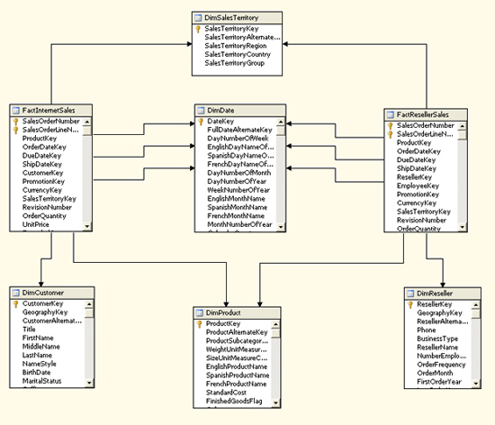

**Define the Calculated Member Profit**

 ([Measures].[Sales Amount] -   ([Measures].[Total Product Cost] + [Measures].[Tax Amt] +

    [Measures].[Freight]))